Project Report Format
- INTRODUCTION
  - Project Overview :
The Housing Market Trends Visualization project is designed to analyze and visualize housing market data using interactive charts and dashboards. The system helps users understand property price trends, compare locations, and gain insights into the real estate market.
  - Purpose :
The purpose of this project is to transform raw housing market data into meaningful visual insights that support decision-making for home buyers, investors, and real estate analysts.
- IDEATION PHASE
  - Problem Statement :
Housing market data is often complex and difficult to analyze. Users need an easy way to understand market trends, price variations, and regional comparisons.
  - Empathy Map Canvas :
Thinks
- Which area is best for investment?
- How are house prices changing?
Feels
- Confused by large datasets.
- Needs reliable market insights.
Says
- "I need clear housing market information."
Does
- Searches housing websites.
- Compares property prices.

  - Brainstorming :
- Housing price trend analysis
- Regional comparison dashboard
- Interactive charts and filters
- Market growth visualization

- REQUIREMENT ANALYSIS
  - Customer Journey map :
• User accesses dashboard.
• User selects location and year.
• System processes housing data.
• Dashboard displays visualizations.
• User analyzes trends and downloads reports.
  - Solution Requirement :
Functional Requirements
- User registration and login.
- Data visualization.
- Trend analysis.
- Report generation.
Non-Functional Requirements
- Usability
- Security
- Reliability
- Performance
- Availability
- Scalability

  - Data Flow Diagram :
Housing Dataset
↓
Data Preprocessing
↓
Data Analysis
↓
Visualization Dashboard
↓
User
  - Technology Stack :
Component | Technology
Frontend | Streamlit
Programming Language | Python
Data Processing | Pandas, NumPy
Visualization | Plotly, Matplotlib
Database | MySQL
Deployment | Streamlit Cloud

- PROJECT DESIGN
  - Problem Solution Fit :
The project solves the challenge of understanding housing market trends by providing clear and interactive visualizations.
  - Proposed Solution :
Develop a dashboard that allows users to explore housing prices, compare locations, and analyze market behavior through visual analytics.
  - Solution Architecture :
Dataset
↓
Data Cleaning
↓
Data Analysis
↓
Visualization Engine
↓
Dashboard
↓
User
- PROJECT PLANNING & SCHEDULING
  - Project Planning :
Sprint 1
- Registration
- Login
Sprint 2
- Housing Data Visualization
- Filters
Sprint 3
- Data Analysis
- Market Trend Comparison
Sprint 4
- Dashboard Completion
- Report Generation
- Testing and Deployment

- FUNCTIONAL AND PERFORMANCE TESTING
  - Performance Testing :
Parameter | Description
Data Rendered | Housing market dataset
Data Preprocessing | Null value removal and cleaning
Filters Used | Year, Location, Property Type
Calculated Fields | Average Price, Growth Rate
Dashboard Design | Multiple visualizations
Story Design | Housing market insights

- RESULTS
  - Output Screenshots
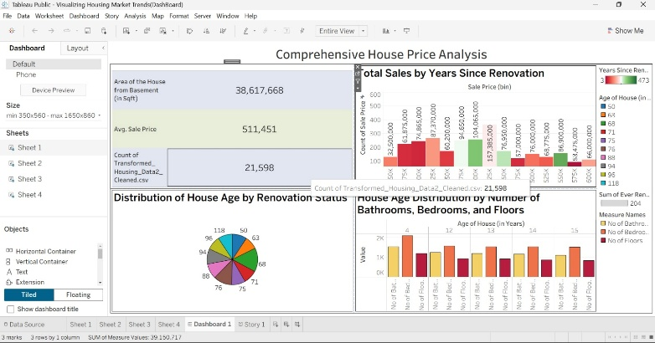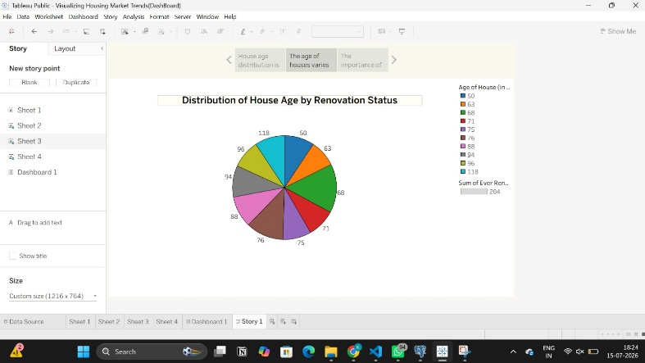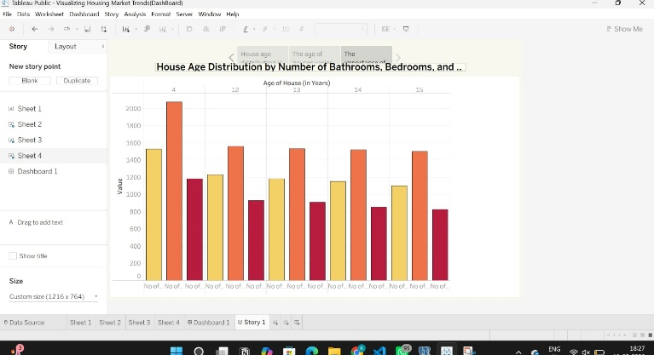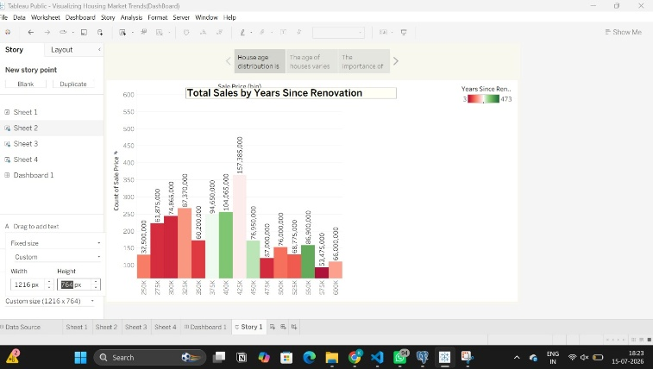
- ADVANTAGES & DISADVANTAGES
Advantages
- Easy visualization of complex housing market data.
- Helps buyers and investors make informed decisions.
- Identifies price trends and market growth patterns.
- Provides location-wise and year-wise analysis.
- Saves time compared to analyzing raw datasets manually.
- Interactive dashboards improve user experience.
- Supports data-driven decision-making in real estate.
Disadvantages
- Results depend on the quality and accuracy of the dataset.
- Requires regular data updates to remain relevant.
- Limited predictions if historical data is insufficient.
- Users may misinterpret visualizations without proper understanding.
- Large datasets may affect dashboard performance.
- Real-time housing data may not always be available.
- Development and maintenance require technical expertise.

- CONCLUSION
The Visualizing the Housing Market Trends project provides an effective way to analyze and understand real estate market data through interactive visualizations and dashboards. By transforming raw housing data into meaningful charts, graphs, and insights, the system helps users identify market trends, compare property prices, and make informed decisions. The project improves data accessibility, supports better investment planning, and demonstrates the practical application of data analytics and visualization techniques in the real estate domain. Future enhancements can include real-time data integration and machine learning-based price prediction to further increase its usefulness and accuracy.
- FUTURE SCOPE 11. APPENDIX
Source Code(if any)
<!DOCTYPE html>
<html lang="en">
<head>
<meta charset="UTF-8" />
<meta name="viewport" content="width=device-width, initial-scale=1.0" />
<title>Housing Trends</title>
<script type="text/javascript" src="https://public.tableau.com/javascripts/api/tableau-2.min.js"></script>
<style>
:root{
--navy-deep:#101826;
--navy:#182335;
--navy-light:#24344c;
--cream:#f4f1ea;
--orange:#eb6a3d;
--orange-dark:#d4552b;
--text-soft:#c8ceda;
--border:#33415c;
}
*{box-sizing:border-box;margin:0;padding:0;}
html{scroll-behavior:smooth;}
body{
font-family:'Segoe UI', 'Helvetica Neue', Arial, sans-serif;
background:var(--cream);
color:#1b2230;
-webkit-font-smoothing:antialiased;
}
h1,h2,h3{font-family:'Georgia', 'Times New Roman', serif; letter-spacing:0.5px;}

/* NAV */
nav.topbar{
display:flex;
align-items:center;
justify-content:space-between;
background:var(--navy);
padding:18px 48px;
position:sticky;
top:0;
z-index:100;
border-bottom:1px solid var(--border);
}
nav.topbar .brand{
color:var(--cream);
font-family:'Georgia', serif;
font-size:1.5rem;
font-weight:700;
letter-spacing:1px;
}
nav.topbar ul{
list-style:none;
display:flex;
gap:36px;
}
nav.topbar ul li a{
color:var(--text-soft);
text-decoration:none;
font-size:0.85rem;
letter-spacing:1.5px;
font-weight:600;
padding-bottom:6px;
border-bottom:2px solid transparent;
cursor:pointer;
transition:color .2s, border-color .2s;
}
nav.topbar ul li a:hover{color:var(--cream);}
nav.topbar ul li a.active{
color:var(--cream);
border-bottom:2px solid var(--orange);
}

/* PAGE SECTIONS - shown/hidden like tabs */
.page{display:none;}
.page.active{display:block; animation:fadein .35s ease;}
@keyframes fadein{from{opacity:0; transform:translateY(6px);} to{opacity:1; transform:translateY(0);}}

/* HOME / HERO */
.hero{
position:relative;
min-height:520px;
display:flex;
align-items:center;
padding:0 60px;
background:
linear-gradient(100deg, rgba(16,24,38,0.92) 20%, rgba(16,24,38,0.55) 65%, rgba(16,24,38,0.25) 100%),
url('https://images.unsplash.com/photo-1560518883-ce09059eeffa?auto=format&fit=crop&w=1600&q=80') center/cover no-repeat;
}
.hero-content{max-width:760px;}
.hero-content h1{
color:var(--cream);
font-size:2.7rem;
line-height:1.25;
margin-bottom:28px;
font-weight:700;
}
.btn-primary{
display:inline-block;
background:var(--orange);
color:#fff;
border:none;
padding:14px 30px;
font-size:0.8rem;
letter-spacing:1.5px;
font-weight:700;
text-decoration:none;
cursor:pointer;
transition:background .2s, transform .2s;
}
.btn-primary:hover{background:var(--orange-dark); transform:translateY(-1px);}

/* ABOUT */
.about-wrap{
max-width:1100px;
margin:70px auto;
padding:0 40px;
display:grid;
grid-template-columns:1fr 1.2fr;
gap:50px;
align-items:center;
}
.about-wrap img{
width:100%;
height:100%;
object-fit:cover;
box-shadow:0 18px 40px rgba(16,24,38,0.25);
}
.about-text h2{
font-size:1.6rem;
color:var(--navy-deep);
margin-bottom:22px;
line-height:1.4;
}
.about-text ul{list-style:none;}
.about-text li{
display:flex;
gap:14px;
margin-bottom:18px;
font-size:0.98rem;
line-height:1.6;
color:#333c4a;
}
.about-text li::before{
content:"✓";
color:var(--orange);
font-weight:700;
flex-shrink:0;
}

/* DASHBOARD */
.section-header{
background:var(--navy);
padding:60px 40px 30px;
text-align:center;
}
.section-header h2{color:var(--cream); font-size:1.7rem;}
.section-header p{color:var(--text-soft); max-width:600px; margin:14px auto 0; font-size:0.95rem;}

.dashboard-wrap{
max-width:1150px;
margin:0 auto;
padding:40px;
background:var(--navy);
padding-bottom:80px;
}
#tableauDashboard{
width:100%;
min-height:800px;
background:#fff;
box-shadow:0 20px 50px rgba(0,0,0,0.35);
}

/* STORY */
.story-wrap{
max-width:1150px;
margin:0 auto;
padding:40px 40px 90px;
background:var(--navy);
}
.story-tabs{
display:flex;
border:1px solid var(--border);
background:var(--navy-light);
}
.story-tab{
flex:1;
padding:20px 22px;
color:var(--text-soft);
font-size:0.85rem;
line-height:1.5;
cursor:pointer;
border-right:1px solid var(--border);
transition:background .2s, color .2s;
}
.story-tab:last-child{border-right:none;}
.story-tab:hover{background:rgba(235,106,61,0.12);}
.story-tab.active{
background:var(--orange);
color:#fff;
font-weight:600;
}
#tableauStory{
width:100%;
min-height:760px;
background:#fff;
box-shadow:0 20px 50px rgba(0,0,0,0.35);
}
.story-nav-arrows{
display:flex;
justify-content:space-between;
margin-top:14px;
}
.story-nav-arrows button{
background:none;
border:1px solid var(--border);
color:var(--cream);
font-size:1.1rem;
width:42px;
height:42px;
cursor:pointer;
border-radius:50%;
transition:background .2s;
}
.story-nav-arrows button:hover{background:var(--orange);}

footer{
background:var(--navy-deep);
color:var(--text-soft);
text-align:center;
padding:24px;
font-size:0.8rem;
letter-spacing:0.5px;
}

@media(max-width:800px){
nav.topbar{padding:16px 20px; flex-direction:column; gap:14px;}
nav.topbar ul{gap:18px; flex-wrap:wrap; justify-content:center;}
.hero{padding:0 24px; min-height:420px;}
.hero-content h1{font-size:1.9rem;}
.about-wrap{grid-template-columns:1fr; margin:40px auto; padding:0 24px;}
.story-tabs{flex-direction:column;}
.story-tab{border-right:none; border-bottom:1px solid var(--border);}
}
</style>
</head>
<body>

<!-- ============ NAV (repeats visually per section, driven by one router) ============ -->
<nav class="topbar">
<div class="brand">Housing Trends</div>
<ul>
<li><a data-page="home" class="active">HOME</a></li>
<li><a data-page="about">ABOUT</a></li>
<li><a data-page="dashboard">DASHBOARD</a></li>
<li><a data-page="story">STORY</a></li>
</ul>
</nav>

<!-- ============ HOME ============ -->
<section id="home" class="page active">
<div class="hero">
<div class="hero-content">
<h1>VISUALIZING HOUSING SALES TRENDS AND ITS PRICES.</h1>
<a class="btn-primary" data-page="about">GET STARTED</a>
</div>
</div>
</section>

<!-- ============ ABOUT ============ -->
<section id="about" class="page">
<div class="about-wrap">
<img src="https://images.unsplash.com/photo-1449844908441-8829872d2607?auto=format&fit=crop&w=800&q=80" alt="Housing development" />
<div class="about-text">
<h2>Visualizing Housing Market Trends: An Analysis of Sale Prices and Features using Tableau</h2>
<ul>
<li>The goal is to address challenges in understanding the factors that influence house prices and sales trends.</li>
<li>By analysing comprehensive housing data, including the total sales by years since renovation, house age distribution by the number of bathrooms, bedrooms, and floors, and the impact of renovations on house age, the company aims to uncover key insights.</li>
<li>Utilizing Tableau for this analysis, the objective is to visualize and interpret patterns in the housing market to inform strategic decisions, optimize pricing strategies, and enhance overall market competitiveness.</li>
</ul>
</div>
</div>
</section>

<!-- ============ DASHBOARD ============ -->
<section id="dashboard" class="page">
<div class="section-header">
<h2>Comprehensive House Data Analysis</h2>
<p>An interactive breakdown of sales, pricing, and renovation patterns across the housing dataset.</p>
</div>
<div class="dashboard-wrap">
<div id="tableauDashboard"></div>
</div>
</section>

<!-- ============ STORY ============ -->
<section id="story" class="page">
<div class="section-header">
<h2>The Story</h2>
<p>Click a slide below to jump to that part of the story.</p>
</div>
<div class="story-wrap">
<div class="story-tabs">
<div class="story-tab active" data-slide="0">House age distribution is more influenced by the number of bedrooms compared to bathrooms and floors.</div>
<div class="story-tab" data-slide="1">The age of houses varies based on their renovation status, providing a comprehensive overview.</div>
<div class="story-tab" data-slide="2">The importance of recent renovations in boosting property sales.</div>
</div>
<div id="tableauStory"></div>
<div class="story-nav-arrows">
<button id="storyPrev">&#8249;</button>
<button id="storyNext">&#8250;</button>
</div>
</div>
</section>

<footer>&copy; 2026 Housing Trends — Data Analytics with Tableau</footer>

<script>
/* =========================================================================
1) PAGE ROUTER — shows/hides the four sections and keeps nav in sync
========================================================================= */
const navLinks = document.querySelectorAll('a[data-page]');
const pages = document.querySelectorAll('.page');

function goToPage(pageId){
pages.forEach(p => p.classList.toggle('active', p.id === pageId));
document.querySelectorAll('nav.topbar a[data-page]').forEach(a=>{
a.classList.toggle('active', a.dataset.page === pageId);
});
window.scrollTo({top:0, behavior:'smooth'});
if(pageId === 'dashboard' && !dashboardLoaded) loadDashboard();
if(pageId === 'story' && !storyLoaded) loadStory();
}

navLinks.forEach(link=>{
link.addEventListener('click', ()=> goToPage(link.dataset.page));
});

/* =========================================================================
2) TABLEAU EMBEDS
-------------------------------------------------------------------------
Paste your Tableau Public "Share" links below (the full public.tableau.com
view URL, e.g. https://public.tableau.com/views/YourWorkbook/YourSheet).
Everything else is already wired up.
========================================================================= */
const TABLEAU_DASHBOARD_URL = "https://public.tableau.com/views/VisualizingHousingMarketTrendsDashBoard/Dashboard1";
const TABLEAU_STORY_URL = "https://public.tableau.com/views/VisualizingHousingMarketTrends_17840456228750/Story1";

let dashboardViz, storyViz;
let dashboardLoaded = false, storyLoaded = false;

function loadDashboard(){
if(TABLEAU_DASHBOARD_URL.startsWith("PASTE_")) {
document.getElementById('tableauDashboard').innerHTML =
'<p style="padding:60px;text-align:center;color:#888;">Add your Tableau dashboard link in the script (TABLEAU_DASHBOARD_URL) to load this view.</p>';
return;
}
const container = document.getElementById('tableauDashboard');
dashboardViz = new tableau.Viz(container, TABLEAU_DASHBOARD_URL, {
hideTabs: true,
hideToolbar: true,
width: container.clientWidth,
height: 800
});
dashboardLoaded = true;
}

function loadStory(){
if(TABLEAU_STORY_URL.startsWith("PASTE_")) {
document.getElementById('tableauStory').innerHTML =
'<p style="padding:60px;text-align:center;color:#888;">Add your Tableau story link in the script (TABLEAU_STORY_URL) to load this view.</p>';
return;
}
const container = document.getElementById('tableauStory');
storyViz = new tableau.Viz(container, TABLEAU_STORY_URL, {
hideTabs: true,
hideToolbar: true,
width: container.clientWidth,
height: 760,
onFirstInteractive: function(){ storyLoaded = true; }
});
}

/* =========================================================================
3) STORY SLIDE NAVIGATION — clicking a tab (or the arrows) jumps the
embedded Tableau story to that exact story point.
========================================================================= */
const storyTabs = document.querySelectorAll('.story-tab');
let currentSlide = 0;

function setActiveSlide(index){
currentSlide = Math.max(0, Math.min(storyTabs.length - 1, index));
storyTabs.forEach((tab,i)=> tab.classList.toggle('active', i === currentSlide));
if(storyViz){
const sheet = storyViz.getWorkbook().getActiveSheet();
if(sheet.getSheetType && sheet.getSheetType() === 'story'){
sheet.setActiveStoryPointIndexAsync(currentSlide);
}
}
}

storyTabs.forEach((tab, i)=>{
tab.addEventListener('click', ()=> setActiveSlide(i));
});

document.getElementById('storyPrev').addEventListener('click', ()=> setActiveSlide(currentSlide - 1));
document.getElementById('storyNext').addEventListener('click', ()=> setActiveSlide(currentSlide + 1));
</script>

</body>
</html>

Dataset Link : https://www.kaggle.com/datasets/rituparnaghosh18/transformed-housing-data-2

GitHub & Project Demo Link :
Github link:
https://github.com/kanchiiswarya/Visualizing-Housing-Market-Trends-An-Analysis-of-Sale-Prices-and-Features-using-Tableau.git

Project Demo link:
https://drive.google.com/file/d/15N0B_rCX4VCBVc50-V2__0dS8biMANqs/view?usp=drivesdk

